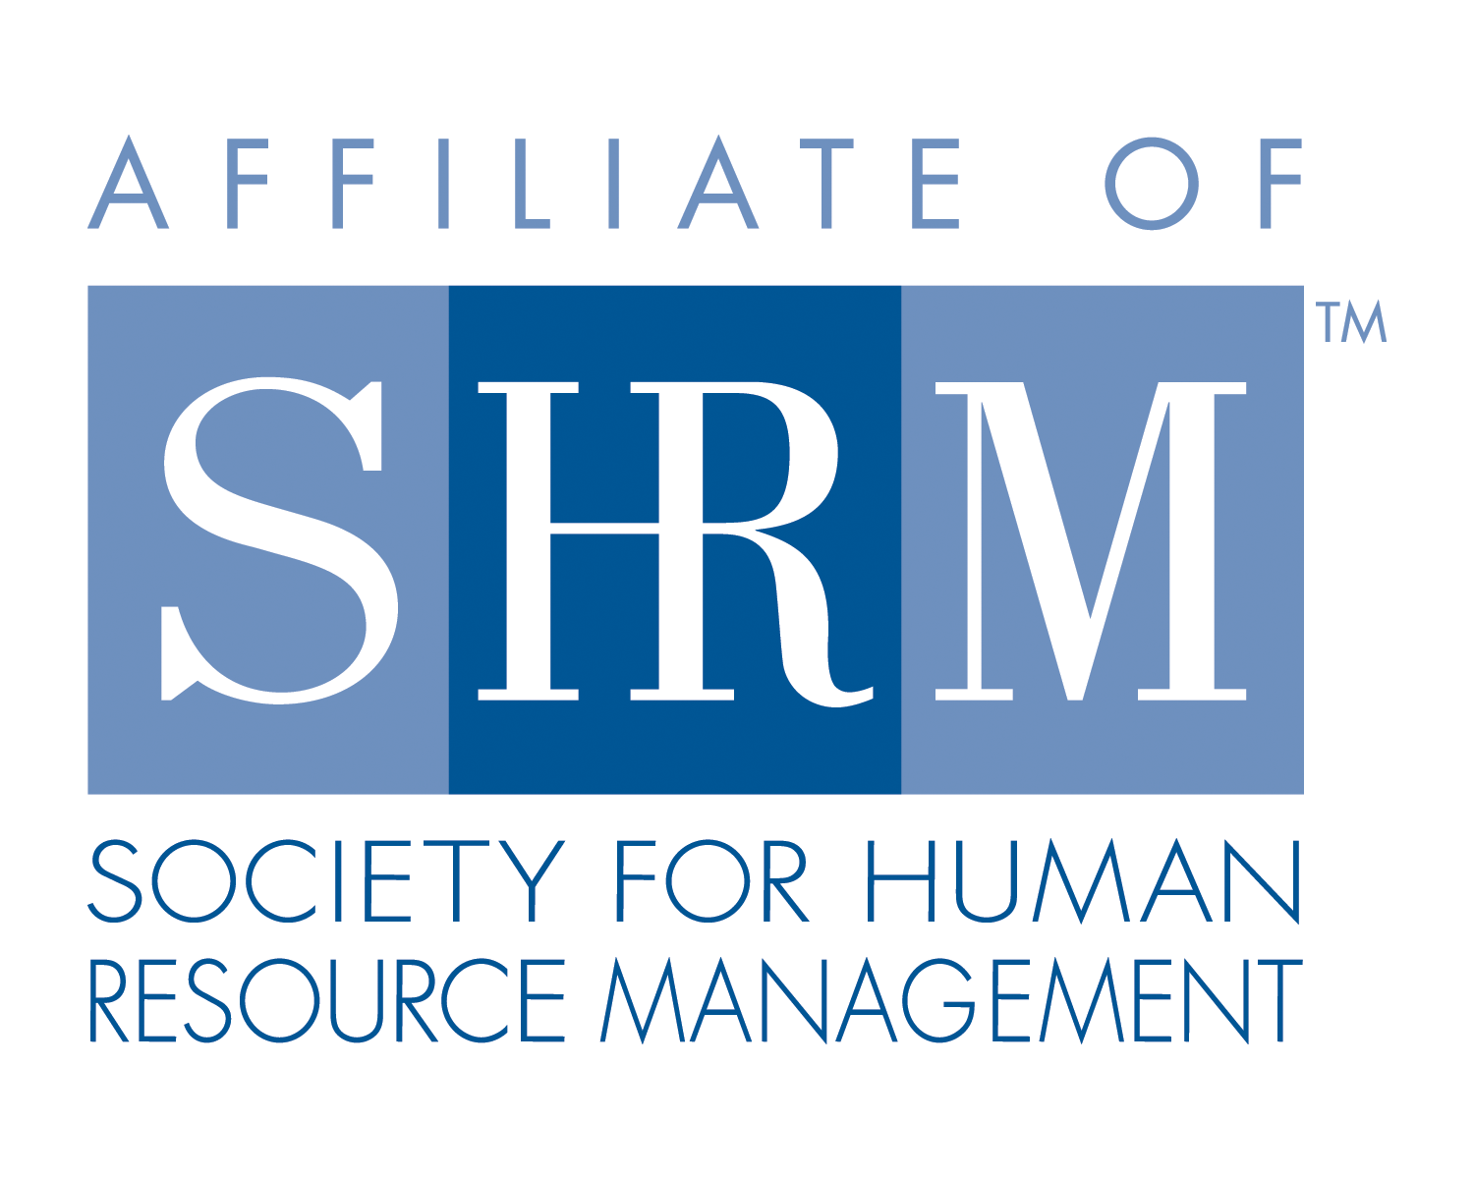
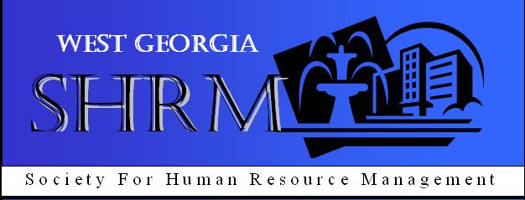

West Georgia SHRM General Meeting
West Georgia Technical College, Troup County Room
August 8, 2013
- Call to Order: Chapter President, Michael Davis called the monthly meeting of West Georgia SHRM to order at 12:00 pm on Thursday, August 8, 2013 at West Georgia Technical College in the Troup County Room.

- General Meeting Minutes were reviewed and approved

- Announcements:

- Chair Reports:
Co-President (M. Davis) – Handouts on the tables
  - 2014 West Georgia SHRM Board Nominations
  - Fair on the Hill 2013 at Lagrange College, August 27th, 5:30pm – 7:30pm
  - Georgia’s State SHRM meeting in Atlanta – Sept. 19
  - Sponsoring a recruitment booth at West Georgia Career Connect Expo and Job Fair on Sept. 26th, 10am – 3pm
  - Volunteers for a dissertation research study on blended workforces by Loraine Allen

Treasurer (K. Redic) – ending balance $10, 957.58

- Speakers: Today’s speaker was Dr. Pamela Scotto Tremblay. Dr. Tremblay spoke on her personal testimony and introduced her book, The Lost Paradigm. Dr. Tremblay’s presentation to the group was about 4 Measures of Success, Types of Resiliency, and 3 Principles for Transformation.

- Adjournment: Adjourned at 12:55 pm.

