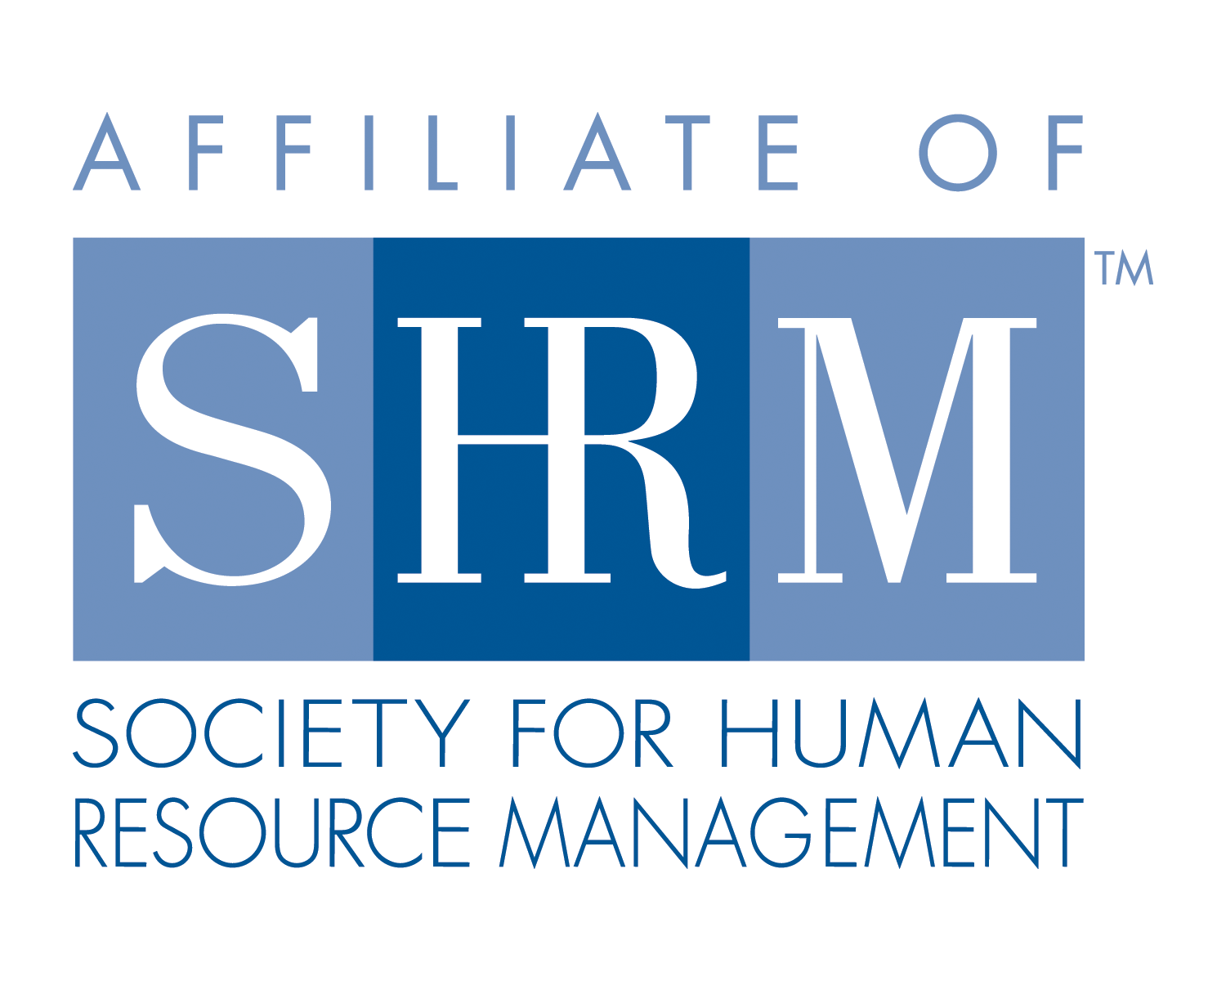
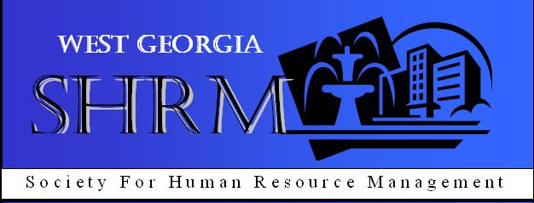

West Georgia SHRM General Meeting
West Georgia Technical College, Troup County Room

- Call to Order: Chapter Co-President, Michael Davis called the monthly meeting of West Georgia SHRM to order at 12:02 pm on Thursday, October 10, 2013 at West Georgia Technical College in the Troup County Room.
  - New Members and Visitors were welcomed

- General Meeting Minutes were review and approved.

- Announcements:
  - Job Openings/Resumes
  - PHR/SPHR Certification Classes @ WGTC (Mon/Wed starting on Nov. 4)
  - Backpack Program (Good Sam Ministry) – bring non-perishable items to West GA SHRM General Meetings.
  - Membership drive for 2013 Q4 Meetings, every member encouraged to bring at least 1 guest to monthly meeting. Two gift cards will be given away; 1 to the member who brings the most guests and 1 to the member who has the most guest join our Chapter.
  - HRCI credits offered for today’s meeting send an email to Dawn Coker or Diana Goldwire.
  - Upcoming Speakers –
- November: Tami Poe - Benefits of National SHRM Membership & Rhonda Owenby – Foundation Benefits
- December – Randy Nix on Legislative update.
- Chair Reports:
Treasurer (K. Redic):
- Opening balance $9, 635.06; Closing Balance $9, 139.13.

- Speakers: Today’s speaker was Mike Stone from Hutchinson Traylor spoke on Patient Protection & Affordable Care Act (PPACA) Part 2 of 2. The second part of the Health Care Reform Training was about Employer Mandate, definition of a large employer is under PPACA, penalties for not offering affordable coverage beginning in 2014 and the next steps.

- Adjournment: Adjourned at 1:00 pm.

Respectfully Submitted,
Naomi Grissett
West Georgia SHRM Secretary 2013

