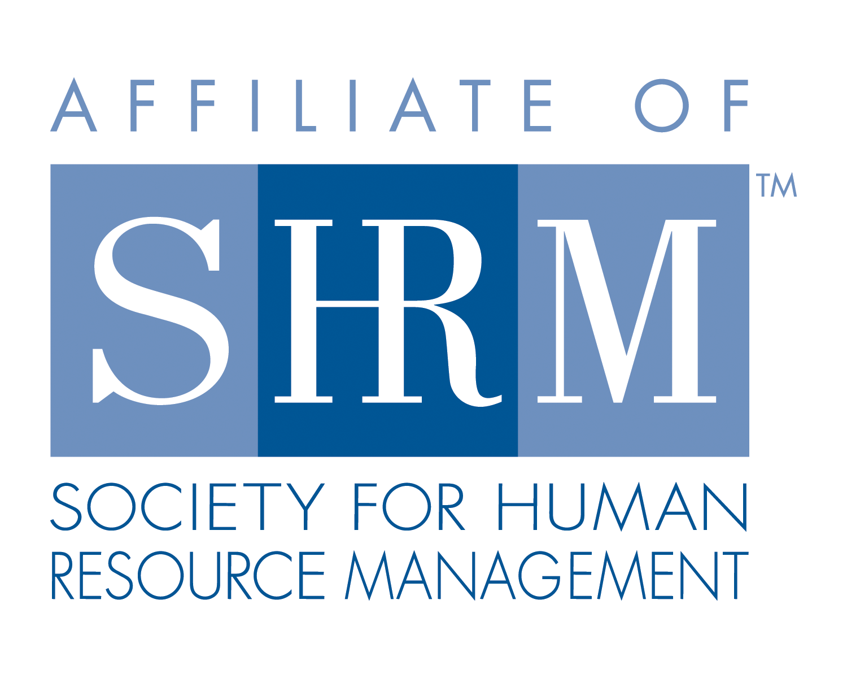


West Georgia SHRM General Meeting
West Georgia Technical College, Troup County Room
September 12, 2013
- Call to Order: Chapter Co-President, Tami Poe called the monthly meeting of West Georgia SHRM to order at 12:00 pm on Thursday, September 12, 2013 at West Georgia Technical College in the Troup County Room.

- General Meeting Minutes were pending

- Announcements:
Co-President (T. Poe):
  - 2014 West Georgia SHRM Board Nominations
  - Georgia’s State SHRM meeting in Atlanta – Sept. 19
  - Community Outreach hosted by Office of Federal Contract Compliance Programs & Georgia Department of Labor- Sept. 17, 10am – 12:30pm
  - Sponsoring a recruitment booth at West Georgia Career Connect Expo and Job Fair on Sept. 26th, 10am – 3pm
  - Volunteers for a dissertation research study on blended workforces by Loraine Allen
  - October – December will be West Georgia SHRM Membership drive meetings

- Chair Reports:
Membership (D. Coker):
- Welcome new member and SHRM Foundation Board member, Rhonda Owensby

Treasurer (K. Redic):
- Ending balance $9,602.06

- Speakers: Today’s speaker was Mike Stone from Hutchinson Traylor spoke on Health Care Reform…Developing Your Strategy, Part 1 of 2. The first part of the Health Care Reform Training was about Notice of Exchanges, What an exchange is, Community Rating and Employer Mandates.

- Adjournment: Adjourned at 12:55 pm.

